G ADITHYA PRASAD
Wi-Fi Training Program

Assignment Questions - Module 2

1. Brief about SplitMAC architecture and how it improves the AP's performance

In splitMAC architecture, the Access point(AP) does the lower MAC functions and Wireless LAN Controller(WLC) does the Upper MAC functions.

The Lower MAC functions done by AP include:
- Frame reception and transmission
- CSMA/CA
  - Listen Before Transmit
  - Backoff Timers
- Ack handling
- Retransmissions
- Fragmentation and re-assembly
- Encryption/Decryption
- Beacon Transmission

The upper MAC functions done by WLC include:
- Authentication / Association management
  - 802.1x Auth
  - WPA2 / WPA3
- Roaming Decisions
- Security Policy enforcements
- Qos
- Load Balancing
- Mobility Management
- Centralization

This splitMAC architecture improves the performance of the APs as it reduces the load on APs, Enforces a centralised way of operation and an efficient way of using the spectrum by adjusting the transmit power and channels.

2. Describe about CAPWAP, explain the flow between AP and Controller

Control and Provisioning of Wireless Access points (CAPWAP) is a protocol used by the WLC and the AP to communicate with each other. Under the CAPWAP architecture, 2 tunnels are established for communication: the Control Tunnel and the Data tunnel.

- Control Tunnel: Manages the APs. Traffic is fully encrypted here. Runs over the port 5246.
- Data Tunnel: Data from AP’s to controller and vice versa travel here. Runs over the port 5247.

Activities in every Tunnel:
i) Control:
- AP Discovery and Join Process
- Config download
- Authentication of AP
- Firmware updates
- Keepalive messages

ii) Data Tunnel:
- Carrying Data
- Encapsulation of 802.11 frames into IP Packets
- Transfer traffic between AP and Controller

Working of CAPWAP:
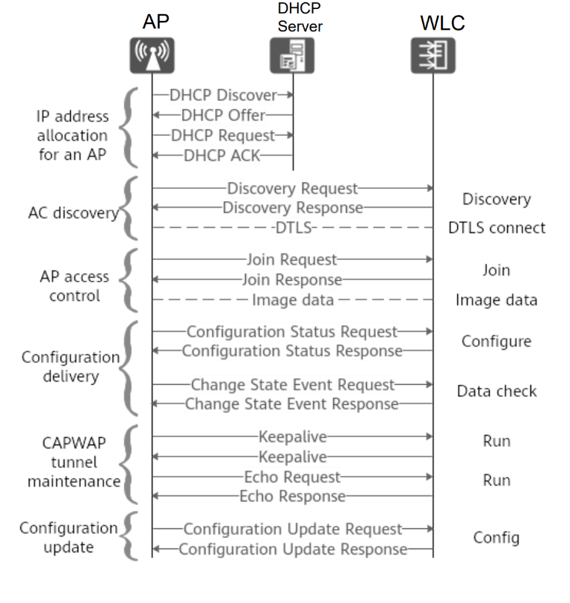

3. Where this CAPWAP fits in OSI model, what are the two tunnels in CAPWAP and its purpose?

CAPWAP operates mainly at:
- Layer 7 (Application Layer) → defines control & management logic between AP and controller
- Uses Layer 4 (Transport Layer) → runs over UDP
- Uses Layer 3 (Network Layer) → runs over IP
CAPWAP = Application-layer protocol transported via UDP/IP

4. What is the difference between Lightweight APs and Cloud-based APs?

Lightweight APs | Cloud Based APs
The WLC is On-premise in the network | WLC is on Remote in some location elsewhere.
The protocol used here is CAPWAP | The protocol used here is HTTP/HTTPs and is API based.
Deployment is highly Complex | Simple deployment as it is simply plug and play type.
The complete architecture is controller dependent. | The dependency here is on Internet and cloud WLC
Scalability is limited | Highly Scalable

5. How the CAPWAP tunnel is maintained between AP and controller

The CAPWAP tunnel between the AP and WLC is maintained through several mechanisms:

- DTLS Session: The control tunnel is secured using DTLS (Datagram Transport Layer Security). This session is established during the initial join process and kept alive as long as the AP is connected. If the DTLS session drops, the AP will re-initiate the discovery and join process.
- Keepalive Messages (Heartbeats): The AP and WLC exchange periodic Echo Request and Echo Response messages over the control tunnel. These act as heartbeats to confirm both ends are alive and reachable. If the AP misses a set number of consecutive keepalive responses, it considers the WLC unreachable.
- Retransmission and Timers: CAPWAP uses retransmission timers for control messages. If an acknowledgment is not received within the timeout period, the message is retransmitted up to a configured number of times.
- AP Failover: If the primary WLC becomes unreachable (keepalives fail), the AP will automatically try to connect to a secondary or tertiary WLC if configured. This ensures continuity of service.
- Data Tunnel Maintenance: The data tunnel (UDP 5247) runs in parallel and carries client traffic. Its continuity depends on the control tunnel remaining active. If the control tunnel fails, the data tunnel also goes down.
- Re-discovery on Failure: If all configured WLCs are unreachable, the AP enters a standalone or disconnected state. Depending on the AP mode (FlexConnect or Local), it may continue serving clients locally until the WLC is reachable again.

6. What’s the difference between Sniffer and monitor mode, use case for each mode

Sniffer Mode:
- In Sniffer mode, the AP captures all wireless packets on a specific channel and forwards them to a packet analysis tool.
- The AP acts as a wireless packet capture device and it does not serve any clients.
- The captured frames include raw 802.11 headers and payload, making it useful for deep packet inspection.
- Use Cases:
  - Troubleshooting client connectivity issues (authentication failures, association problems).
  - Diagnosing protocol-level problems in the wireless network. - Security audits to inspect unencrypted traffic.
  - Analyzing specific channel behavior.

Monitor Mode:
- In Monitor mode, the AP passively scans all channels to detect rogue APs, rogue clients, and wireless intrusions.
- The AP does not serve any clients. It continuously scans and reports findings to the WLC.
- Used as part of a Wireless Intrusion Prevention System (WIPS).
- Use Cases:
  - Detecting and locating rogue APs in the network.
  - Identifying unauthorized clients trying to connect.
  - Spectrum monitoring across all channels.
  - IDS/IPS functionality for wireless networks.

The key difference is that Sniffer mode captures packets on one channel and sends them to an external analysis tool. Whereas, the Monitor mode scans all channels and reports to the WLC for security and intrusion detection and no external tool needed.

7.If WLC deployed in WAN, which AP mode is best for the local network and how?

When the WLC is deployed in the WAN (remote/cloud location), the best AP mode for the local network is FlexConnect mode (previously known as Hybrid-Remote Edge AP or H-REAP).

Advantages of FlexConnect:

FlexConnect allows the AP to locally switch client traffic without sending it all the way to the WLC over the WAN. This is critical because Without FlexConnect, all client data would have to travel through the CAPWAP data tunnel to the remote WLC and back — wasting WAN bandwidth and adding significant latency and with FlexConnect, the AP can forward client data directly to the local network (local switching), reducing WAN dependency.

Working of FlexConnect:

- Connected State (WLC reachable):
  - - Control traffic (authentication, configuration) goes through the CAPWAP control tunnel to the WLC over WAN.
  - - Client data is switched locally at the AP — it does not go to the WLC.
  - - The WLC still handles authentication (802.1X/RADIUS) and policy.

- Standalone State (WLC unreachable — WAN link down):
  - - The AP continues to serve clients using its locally cached configuration. - Clients can still connect and access local resources.
  - - Authentication uses locally cached credentials if the RADIUS server is also remote.

This makes FlexConnect ideal for branch offices, remote sites, or any deployment where the WLC is far away over a WAN link.

8. What are challenges if deploying autonomous APs (more than 50) in large network like university

Deploying more than 50 autonomous APs in a large network like a university presents significant challenges:

- Management Complexity: Each autonomous AP must be configured individually — there is no central controller. With 50+ APs, making a simple change (like updating the SSID password or security policy) requires logging into each AP separately, which is time-consuming and error-prone.

- Inconsistent Configuration: Without centralized management, different APs may end up with slightly different configurations, leading to inconsistent user experience across the campus.

- No Seamless Roaming: Autonomous APs do not support seamless Layer 2 roaming. When a student moves from one building to another, they may experience disconnection and re-authentication, disrupting ongoing sessions.

- No Centralized Security Policy: Enforcing uniform security policies (WPA3, 802.1X authentication, ACLs) across all APs is difficult. Each must be configured manually and consistently.

- RF Management: Autonomous APs cannot coordinate channel selection and transmit power automatically. This leads to channel interference and coverage gaps in high-density environments like lecture halls.

- No Rogue AP Detection: Autonomous APs lack the ability to detect rogue APs or unauthorized devices on the network.

- Firmware Updates: Updating firmware on 50+ APs individually is a major operational overhead and may lead to version inconsistencies.

- Scalability: Adding new APs or expanding coverage requires significant manual effort compared to a controller-based deployment.

9. What happens on wireless client connected to Lightweight AP in local mode if WLC goes down.

When a Wireless LAN Controller (WLC) goes down and the Lightweight AP is in Local Mode, the following happens:

1. CAPWAP Tunnel Drops: The AP detects that the WLC is unreachable when keepalive (Echo Request/Response) messages stop being acknowledged after the retry threshold is exceeded.

2. Existing Clients are Disconnected: In Local mode, all client data is forwarded through the CAPWAP data tunnel to the WLC. When the WLC goes down, the data tunnel collapses. All currently connected clients lose their wireless connection immediately.

3. AP Attempts Failover: The AP attempts to connect to a secondary WLC (if configured). If a secondary or tertiary WLC is available and reachable, the AP will re-establish the CAPWAP tunnel with it and clients can reconnect.

4. No Local Switching: Unlike FlexConnect mode, Local mode APs cannot switch traffic locally. Without the WLC, the AP cannot forward any client data — there is no fallback local operation.

5. AP Enters Discovery State: If no backup WLC is available, the AP will continuously try to discover and join a WLC. During this time, the AP radio may stop beaconing or clients attempting to connect will be rejected.

6. SSIDs May Go Down: The SSIDs broadcast by the AP will typically go offline since the AP cannot operate independently in Local mode.

Summary: In Local mode, WLC failure = complete loss of wireless service on that AP. This is why FlexConnect mode or having a redundant WLC (HA pair) is recommended for critical deployments.

